Neo-Primitivism (Russian: Neo-primitivizm)
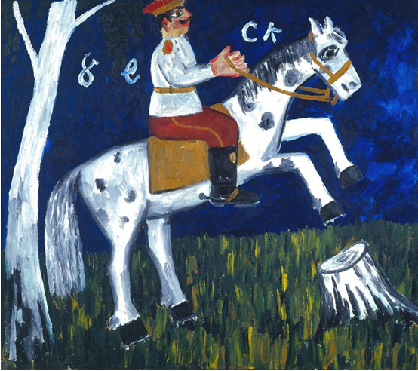
http://www.tate.org.uk/art/artworks/larionov-soldier-on-a-horse-t0076
Mikhail Larionov: Soldier on a Horse, c.1912, Oil on canvas, 87x99cm. Collection: Tate Modern, London.
Image and reproduction rights need to be sought from Tate Modern in London.
Copyright needs to be sought from ADAGP in Paris, or DACS (representing ADAGP in the UK) or ARS (representing ADAGP in the USA).

A style-label employed by the Muscovite avant-garde in the early 20th century to describe forms of visual art and poetry that were tendentiously crude in style and socially and politically contentious in terms of subject matter. In the field of painting the style was chiefly developed by MIKHAIL LARIONOV and NATALIA GONCHAROVA as well as by members of the Donkey’s Tail and Target groups of which they were the leaders. In poetry Neo-primitivism was most consistently explored by Velimir Khlebnikov (1885-1922) and Alexei Kruchenykh (1886-1968), with whom the painters frequently collaborated. Neo-primitivism was not only oppositional to the polite and refined culture of the status-quo but also intensely nationalistic, seeing itself as the inheritor of indigenous artistic practices that had been erased under the Westernising reforms of Peter the Great. Whilst initially inspired by Western avant-garde modernism, the Neo-primitives quickly disassociated themselves from Western practices to find inspiration in the soil of Russia. Their aim was to reinvigorate Russian art by reference to the expressive qualities of icon painitng, the lubok (Russian woodcut print), peasant embroidery, the painted tray and signboard, and the ancient Russian fertility statutes found in the steppe landscape.

The style originated in 1909 with works such as LARIONOV’S Walk in a Provincial Town (Moscow: Tretiakov Gallery), a scathing lubok-style parody of middle-class manners, and a series of down-to-earth peasant paintings by GONCHAROVA such as Planting Potatoes (Paris: Musée National d’Art Moderne). These works were characterized by a laconic use of line, strong colouring, flatened picture spaces, stylized forms and an expressive sense of texture (faktura), the latter being identified as the key characteristic of the Russian folk art tradition as well as a weapon against the polished surfaces of Academic painting and, metaphorically, the ‘polished’ culture of the middle-class. The style blossomed duirng 1910-1912 with an extensive series of Soldier paintings by Larionov which explored the gritty and vulgar life of the ‘squaddie’ in the barracks, a series of controversial Venus paintings on the theme of contemporary prostitution, as well as a series entitled The Seasons (Paris: Musée National d’Art Moderne & Moscow: Tretiakov Gallery), a celebration of Russian peasant life and folk belief, which synthesised the style of the icon, lubok, signboard, peasant embroidery, graffiti and the primitive art of the Siberian shamans.

Neo-primitivism found its most diverse and striking expression in the work of Goncharova. Her paintings on the theme of the Russian peasantry, such as Washing Linen (Moscow: Tretiakov Gallery) and Bread-Seller (Paris: Musée National d’Art Moderne), address the plight of working women both in the countryside and in the new urban centres, whilst a series of paintings entitled Jews explore the difficulties of the ethnic minorities in the pale of settlement. In addition Goncharova executed a large number of religious works in the style of the old Russian icons and church frescos. Seen as an attack on the Orthodox establishment, because of their coarse treatment and expressive textures, works such as The Evangelists (St. Petersburg: Russian Museum) were removed from exhibition by the Public Censor. During 1911 Goncharova increasingly employed allegory in her Neo-primitive work and this is especially noticeable in The Harvest and The Vintage series (Paris: Musée national d’Art Moderne; Moscow: Tretiakov Gallery et al.) which narrate an apocalyptic judgement against her society.

KAZIMIR MALEVICH was also a key exponent of Neo-primitivism. The gauche colour, strong texture, ungainly forms and apparently careless execution, seen in works such as Floor Polishers of 1911 (Amsterdam: Stedelijk Museum), is typical of the style. Other pratitioners included Alexander Shevchenko (1883-1848), who published a manifesto entitled Neo-primitivism in November 1913, David Burliuk (1882-1967), Vladimir Burliuk (1886-1917), Pavel Filonov (1883-1941) and, for a short while, VLADIMIR TATLIN. In the field of Neo-primitive poetry Alexei Kruchenykh and Velimir Khlebnikov both investigated the expressive possibilities of the ‘primitive’ word. Inspired by the glossolalia of shamans and religious dissenters, they dispensed with syntax, rhyme and punctuation, and wrote a substantial body of poetry on primitive themes in a stream of consciousness style. These Neo-primitive poems were published in the form of lubok-style books that were illustrated by the artists. Key examples include A Game in Hell (Igra v adu), illustrated by Goncharova, and World Backwards (Mir s kontsa), illustrated by Goncharova, Larionov, Tatlin and others.

Neo-primitive painting shared much in common with the work of DIE BRÜCKE but was distinctive in its appeal to the national spirit and in its genuine attempt to define a form of modern Russian art that was grounded in indigenous traditions. In stylistic terms it was the most radical of the ‘expressionist’ traditions existing in European art in the years before the First World War and in poetry its emphasis on discovering the expressive quality of pure sound, divorced from meaning, prepared the way for the development of the Russian Formalist school.

Reading

Bowlt, J., Misler, N. & Petrova, E. (2013), The Russian Avant-Garde, Siberia and the East: Kandinsky, Malevich, Filonov, Goncharova. Firenze : Palazzo Strozzi

Compton, S. (1978), The World Backwards: Russian Futurist Books 1912-1916. London: British Library

Eganbiuri, Eli (1913), Natalia Goncharova. Mikhail Larionov, Moscow : Miunster.

Parton, A. (1993), Mikhail Larionov and the Russian Avant-Garde, Princeton / London: Princeton University Press / Thames & Hudson

Parton, A. (2010), Goncharova: The Art and Design of Natalia Goncharova, Woodbridge, UK: Antique Collectors’ Club

Sharp, J.A. (2006), Russian Modernism between East and West: Natal’ia Goncharova and the Moscow Avant-Garde, Cambridge: Cambridge University Press

Shevchenko, A. (1912), Neo-primtivizm, Moscow: Izd. Avtora. Translated into English in Bowlt, J. Russian Art of the Avant-garde: Theory and Criticism 1902-1934, New York: Viking Press, pp. 41-54

Warren, Sarah (2013): Mikhail Larionov and the Cultural Politics of Late Imperial Russia, Farnham (UK): Ashgate

Electronic Sources
Kramer, C. (2002): “Natalia Goncharova: Her Depiction of Jews in Early 20th Century Russia”, in Woman’s Art Journal, Vol. 23, No. 1, Spring-Summer, 2002, pp. 17-23
http://www.jstor.org/stable/10.2307/1358963

Warren, S. (2003), “Spent Gypsies and Fallen Venuses: Mikhail Larionov's Modernist Primitivism”, in Oxford Art Journal Vol. 26, No. 1, 2003, pp. 25-44. (Available via pay site):
http://oaj.oxfordjournals.org/content/26/1/25.full.pdf

